ADD JAR /home/training/Desktop/json-serde-1.3.6-SNAPSHOT-jar-with-dependencies.jar

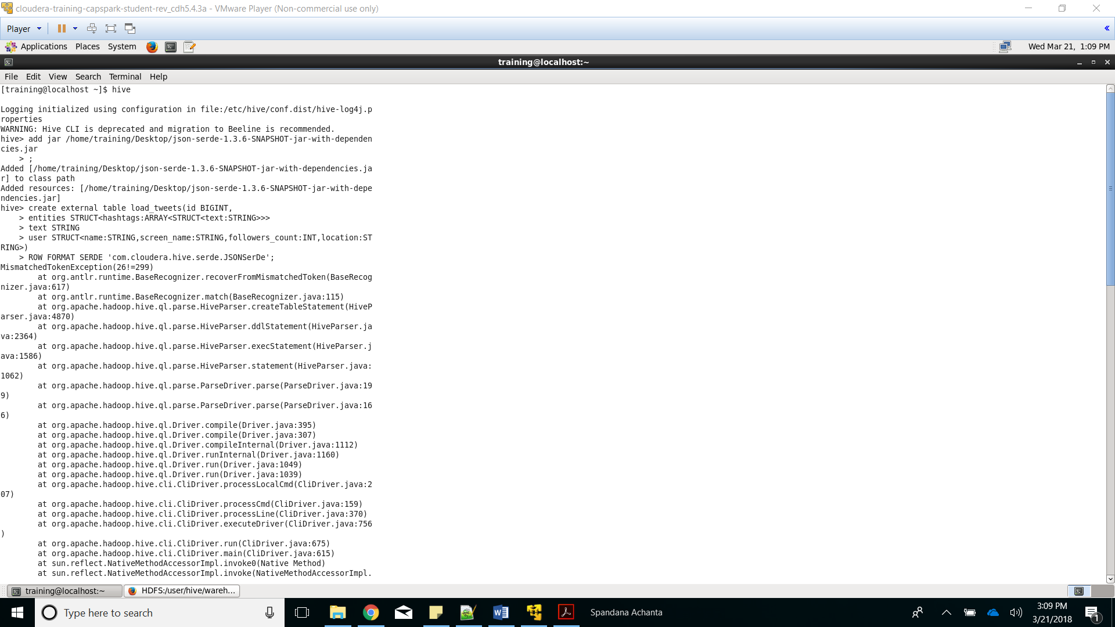

Added the JSON Serde to hive resources to use for manipulating JSON files

create external table load_tweets(id BIGINT,

created_at STRING,

place STRUCT<full_name STRING>,

entities STRUCT<hashtags:ARRAY<STRUCT<text:STRING>>>,

text STRING,

user STRUCT<name:STRING,screen_name:STRING,followers_count:INT,location:STRING>

)

ROW FORMAT SERDE 'org.openx.data.jsonserde.JsonSerDe';

LOAD DATA LOCAL INPATH 'Desktop/tweet2.json' INTO TABLE load_tweets;

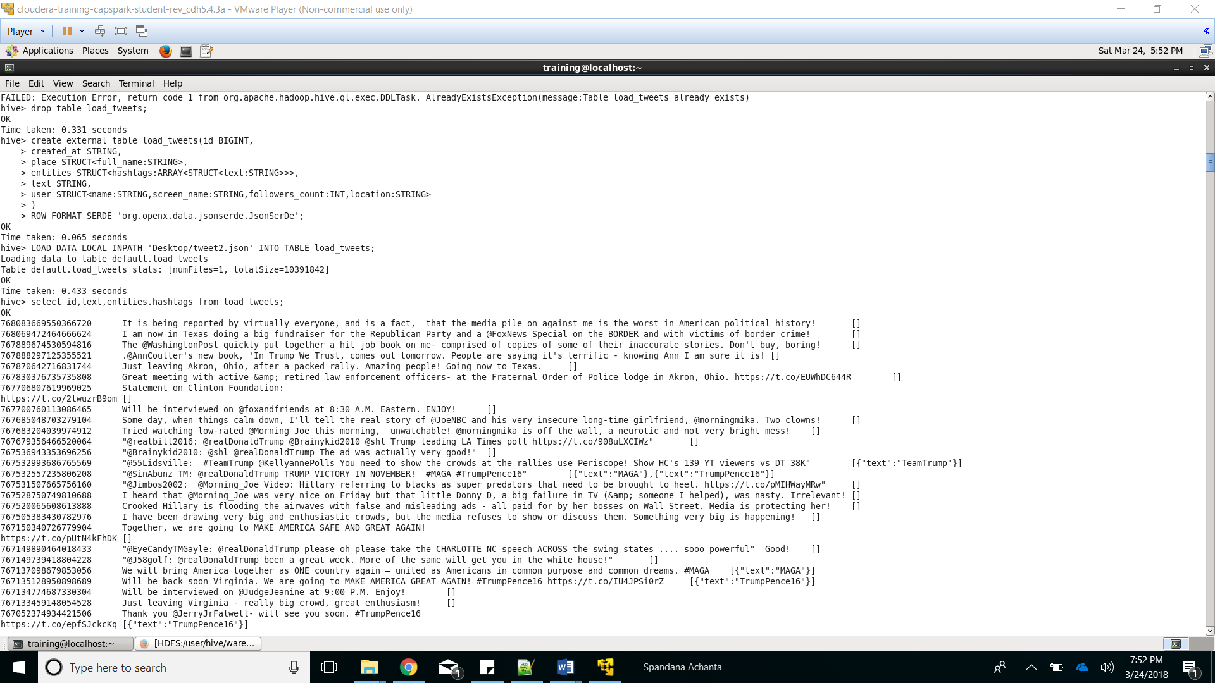

Displaying some of the data to verify

Creating table to store tweet data

create view tweet_hashtags as select id,entities.hashtags.text as words from load_tweets;

create table hashtags as select hashtag from tweet_hashtags LATERAL VIEW explode(words) wordview as hashtag

select hashtag,count(hashtag) as Occurrences from hashtags group by hashtag order by Occurrences desc;

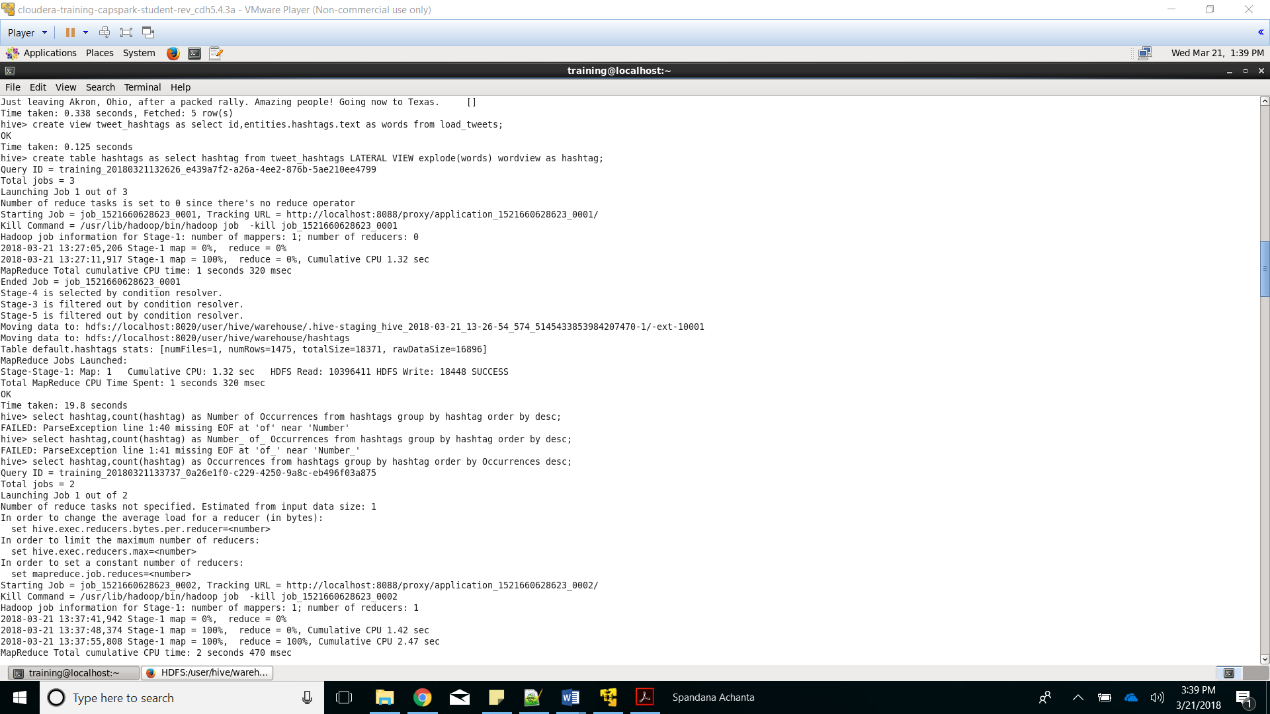

Counting occurrences of each hashtag and ordering from highest to lowest occurence

Created table hashtags splits each word in hashtag text to separate rows and stores in column hashtag

Created view tweet_hashtags that stores id, and text of hashtags from load_tweets

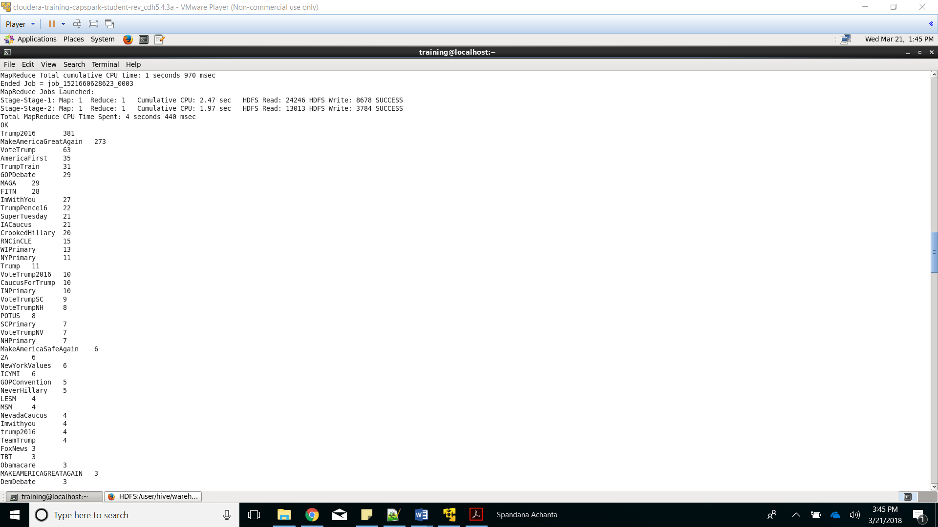

Result of previous query displayed

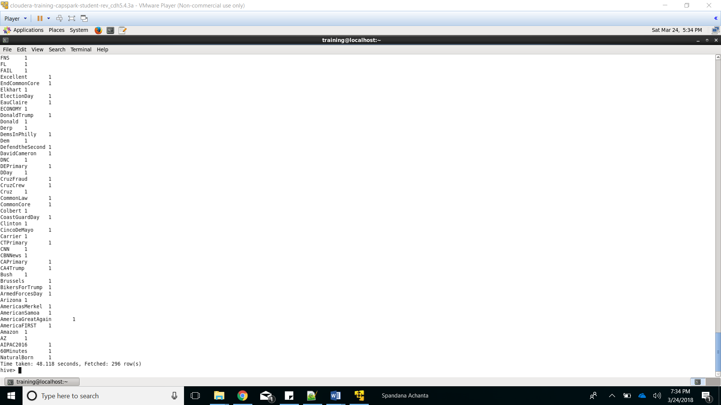

There were 296 distinct hashtags

*Here I assumed that we are going to find the states from where Trump has tweets the most*

Create TABLE tweet_location as

select loc.id, loc.loc_details[0] as city, loc.loc_details[1] as state from

(select id,split(place.full_name,',')as loc_details from load_tweets)loc;

select state, count(id) tweet_count from tweet_location group by state order by tweet_count desc;

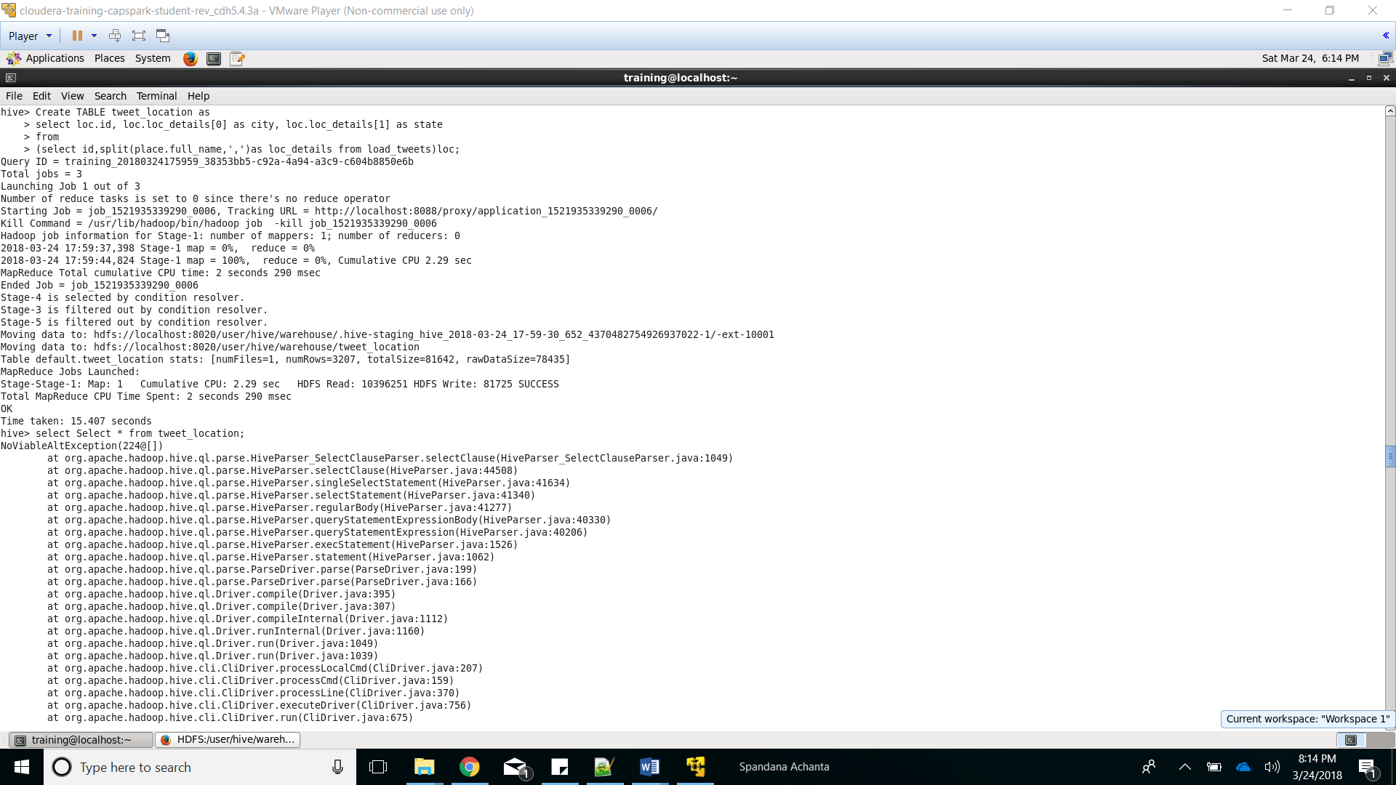

Created table named tweet_location to get separate lines for location level details of the tweet

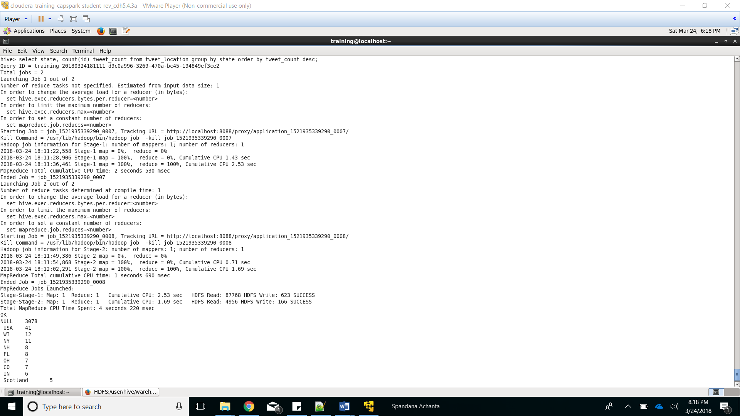

Number of tweets made grouped by different states is displayed.

Neglecting ‘Null’ and ‘USA’ the most active tweets were made from Wichita

*Here I assumed that we are going to find the states by the location in the user section of the tweets*

select user.location, count(id) as count from load_tweets group by user.location;

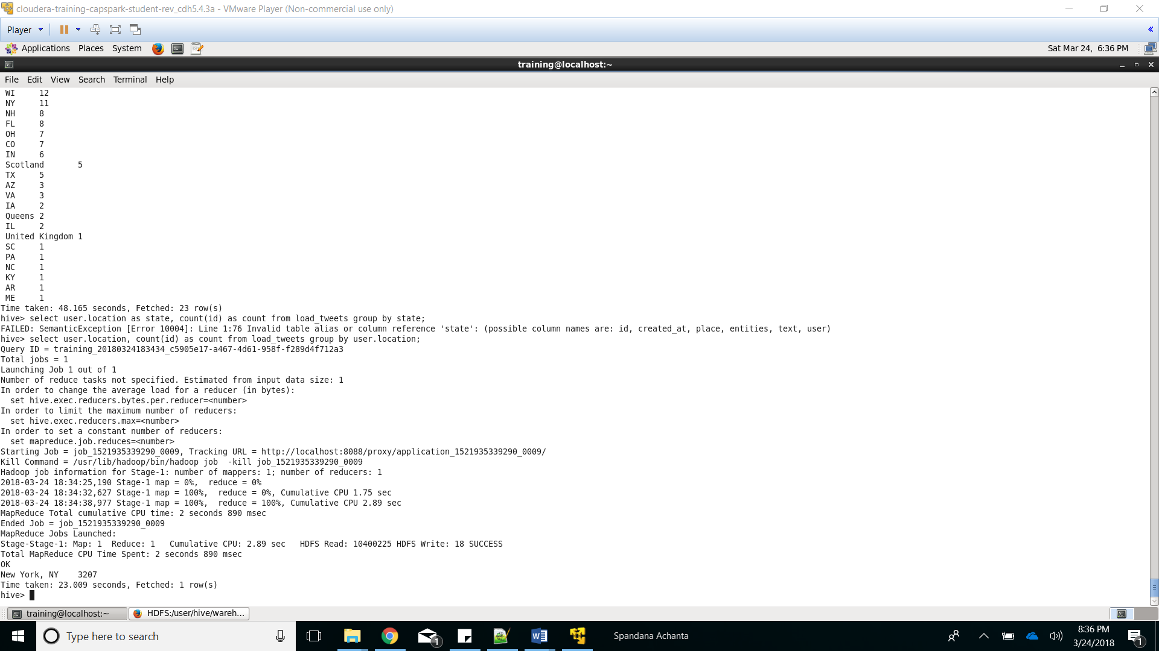

This query gives the location of the user profile that has highest tweets which is New York

create table followers as select user.name,user.followers_count from load_tweets;

select name,followers_count from followers order by followers_count desc limit 10;

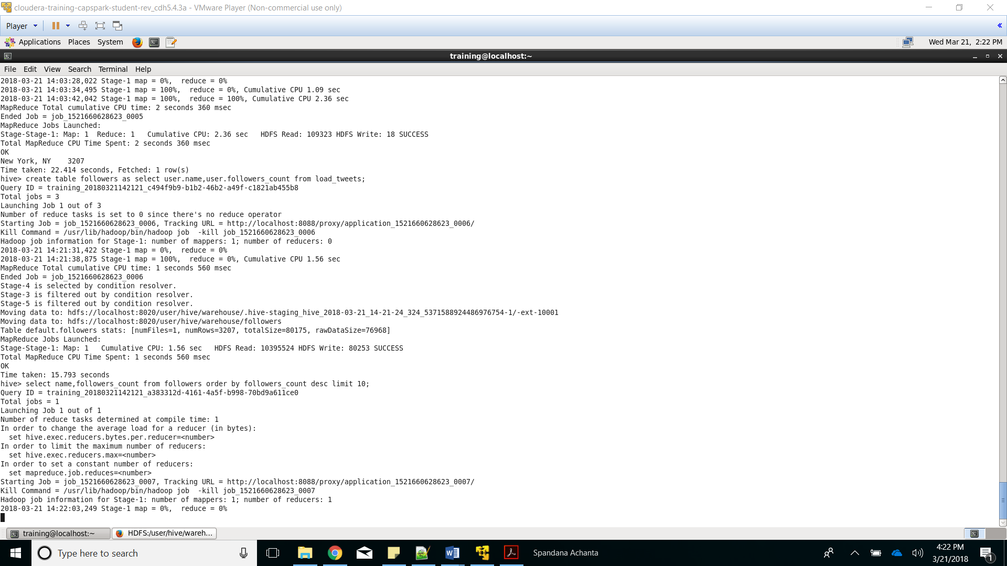

Creating table called ‘followers’ to store data about user name corresponding followers_count

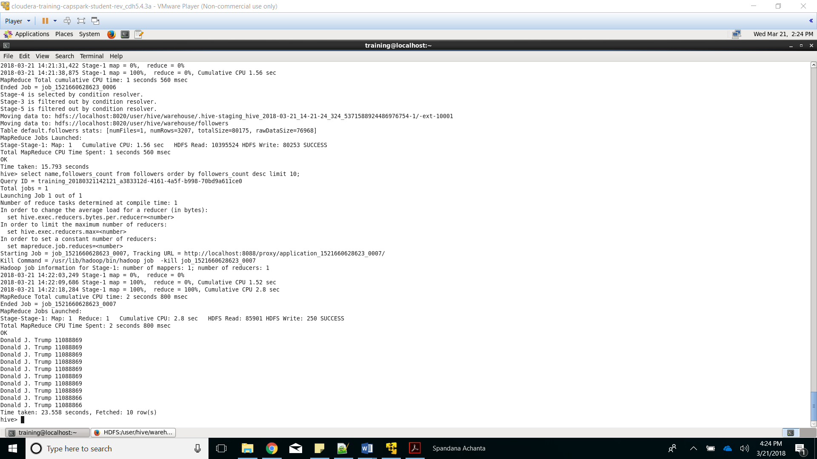

Top 10 users with highest followers_count

create table split_words as select id,split(text,' ') as words,FROM_UNIXTIME(UNIX_TIMESTAMP(created_at,"EEE MMM d HH:mm:ss Z yyyy"),'yyyy-MM-dd') as date, user.name as name from load_tweets;

select * from split_words limit 5;

create table tweet_words as select id,date,name,word from split_words LATERAL VIEW explode(words) w as word;

select * from tweet_words limit 5;

create table dictionary(word string,score int)

ROW FORMAT delimited

FIELDS TERMINATED BY '\t';

Load data local inpath 'Desktop/dictionary.txt into table dictionary;

select * from dictionary limit 5;

create table word_join as select tweet_words.id,tweet_words.word,tweet_words.date,tweet_words.name,dictionary.score from dictionary RIGHT OUTER JOIN tweet_words ON dictionary.word=tweet_words.word;

select * from word_join limit 5;

select id,name,date,AVG(score) as rating from word_join group by id,date,name order by rating desc;

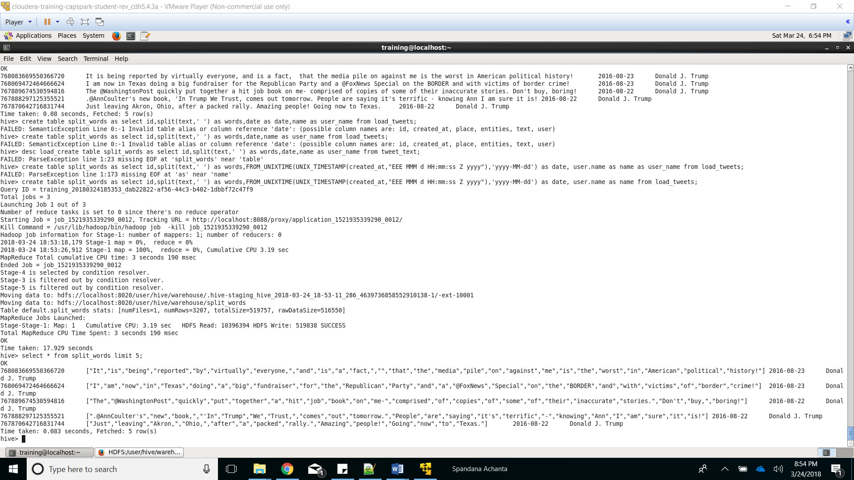

Created a table called split_words that stores tweet id and words from each tweet collected in the form of an array

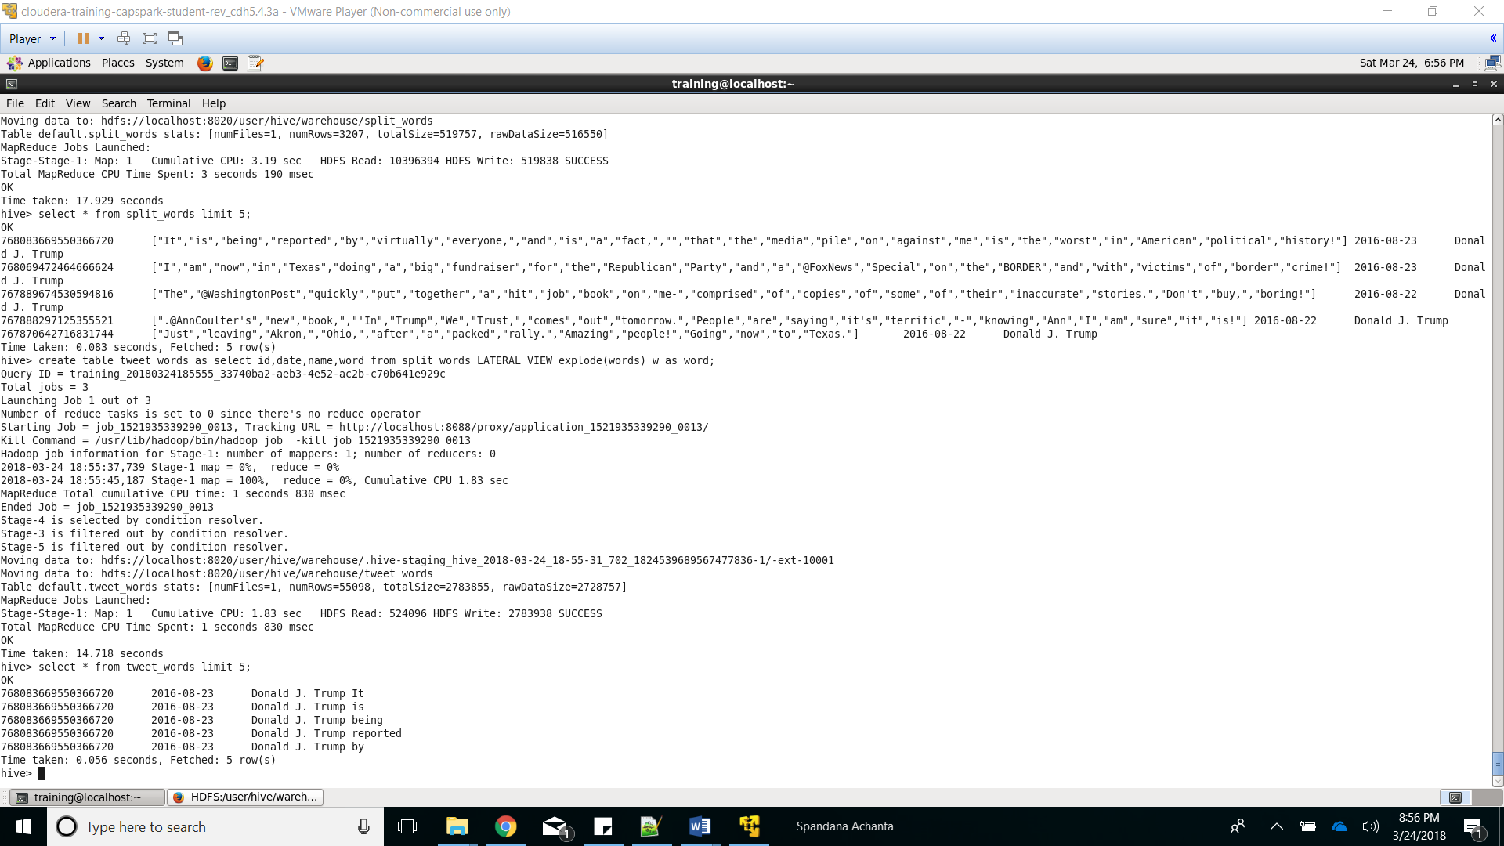

Created a table named tweet_words that stored each word of each tweet in a different row

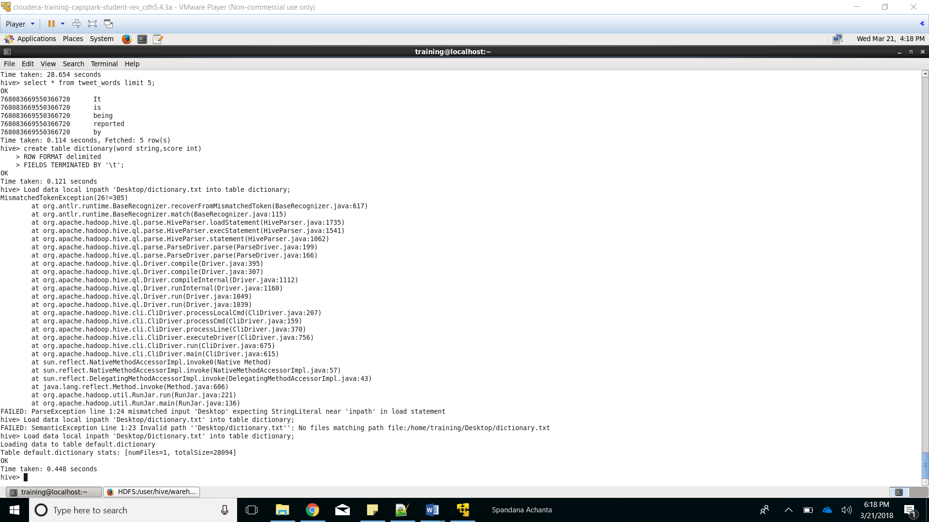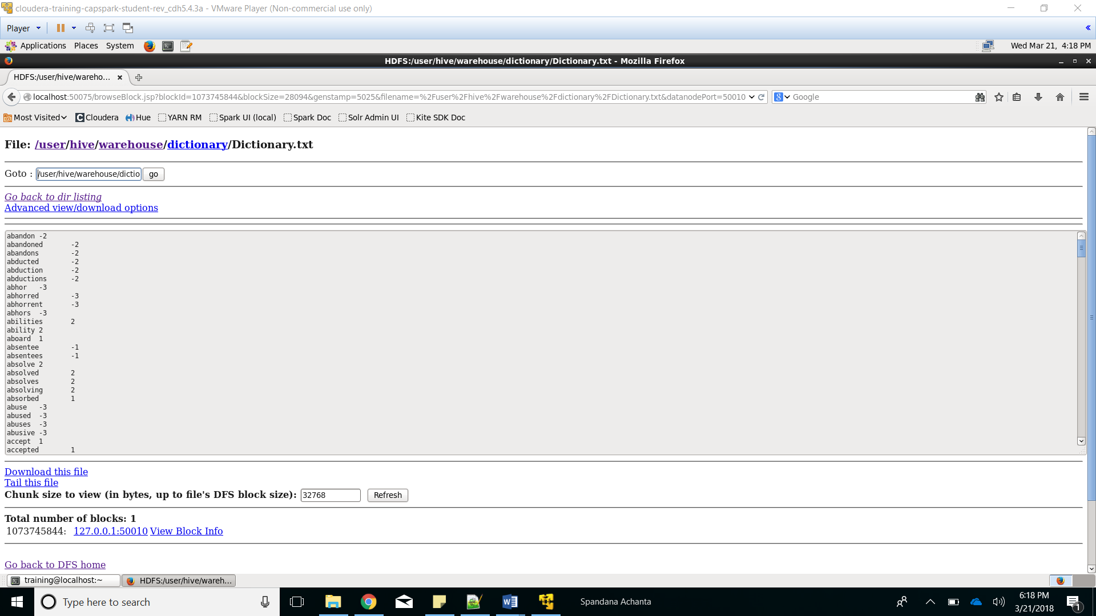

Validating the creation and loading of dictionary data

Loaded the Dictionary.txt file into the created table

Created table to store the dictionary containing for rating of words

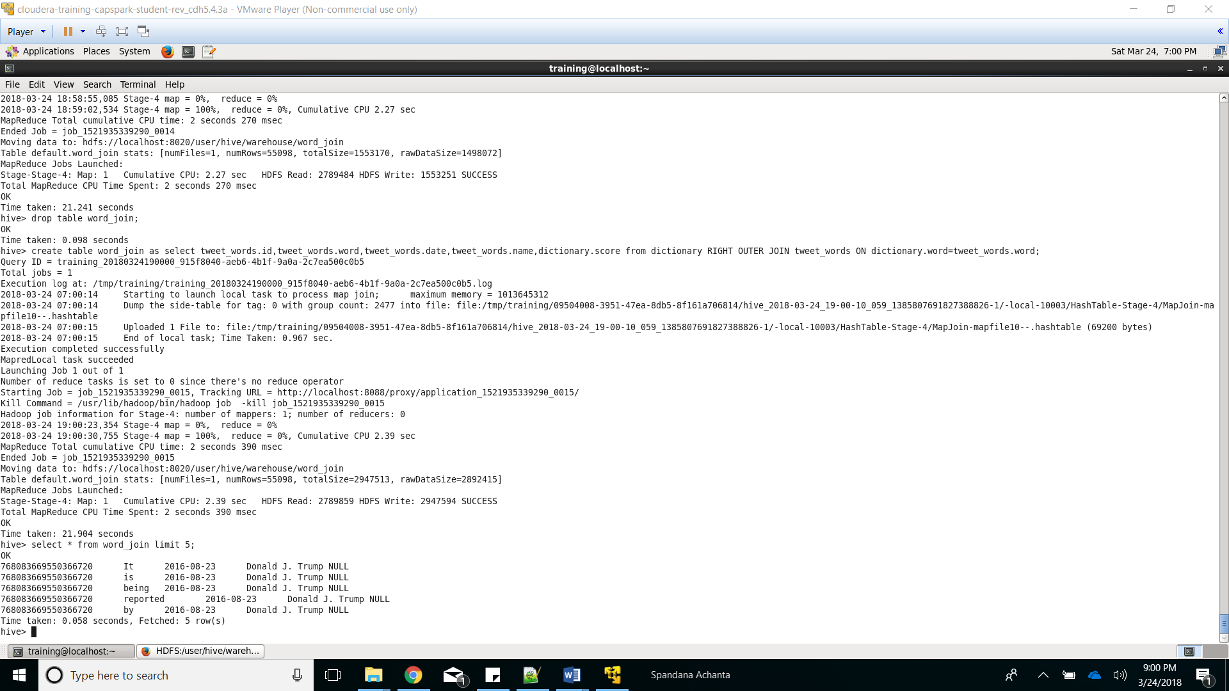

Verifying contents of the join table

Created a join between tweet_words and dictionary

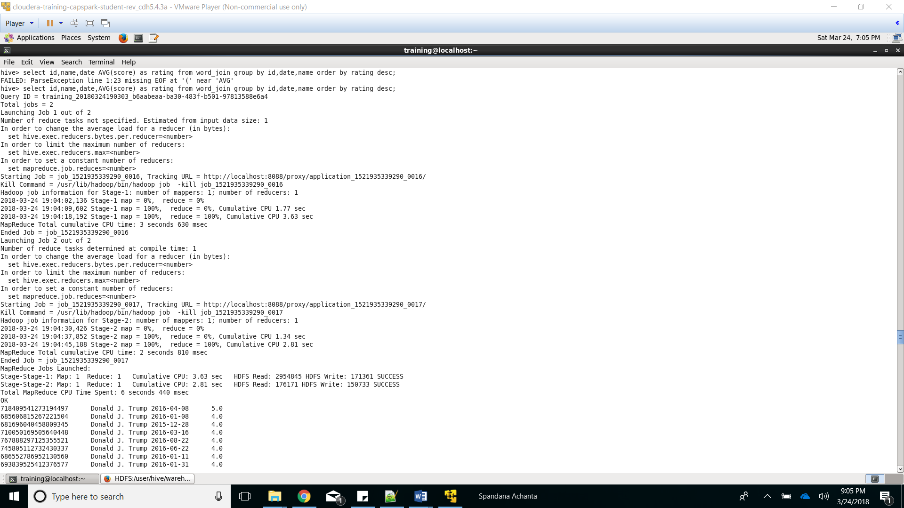

Displaying the result of the select query

Calculating the average rating for each tweet based on score for each word in the tweet

Create table Final_sentiment AS

select id,name,date,avg(score),"Positive" as sentiment from word_join group by id,date,name having avg(score) > 0

UNION ALL

select id,name,date,avg(score),"Negative" as sentiment from word_join group by id,date,name having avg(score) < 0

UNION ALL

select id,name,date,avg(score),"None" as sentiment from word_join group by id,date,name having avg(score) is NULL;

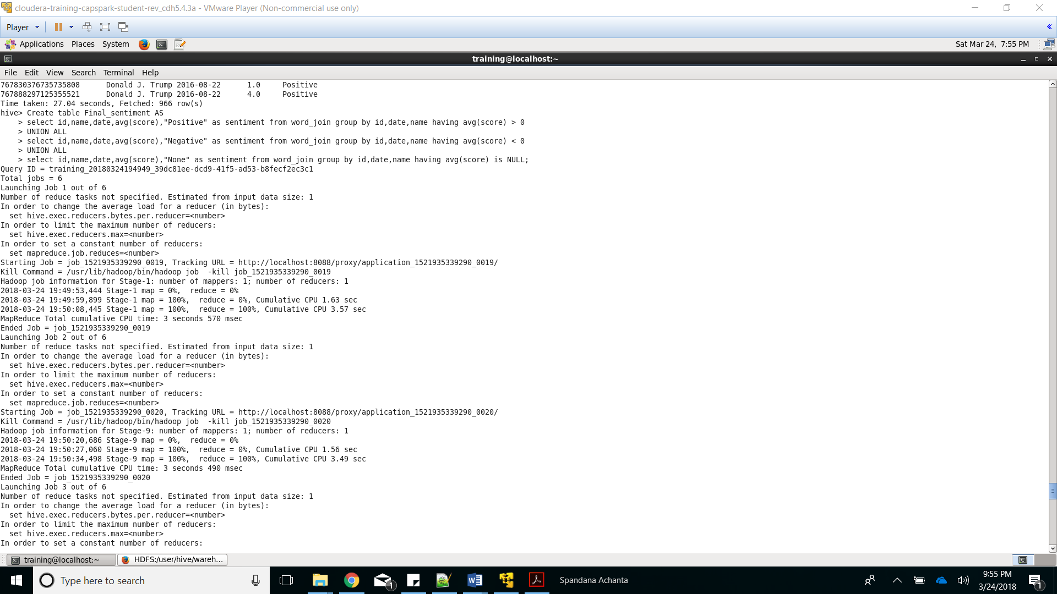

Created a table name ‘Final_Sentiment’ to store the result of previous query with a new column sentiment showing positive negative or None

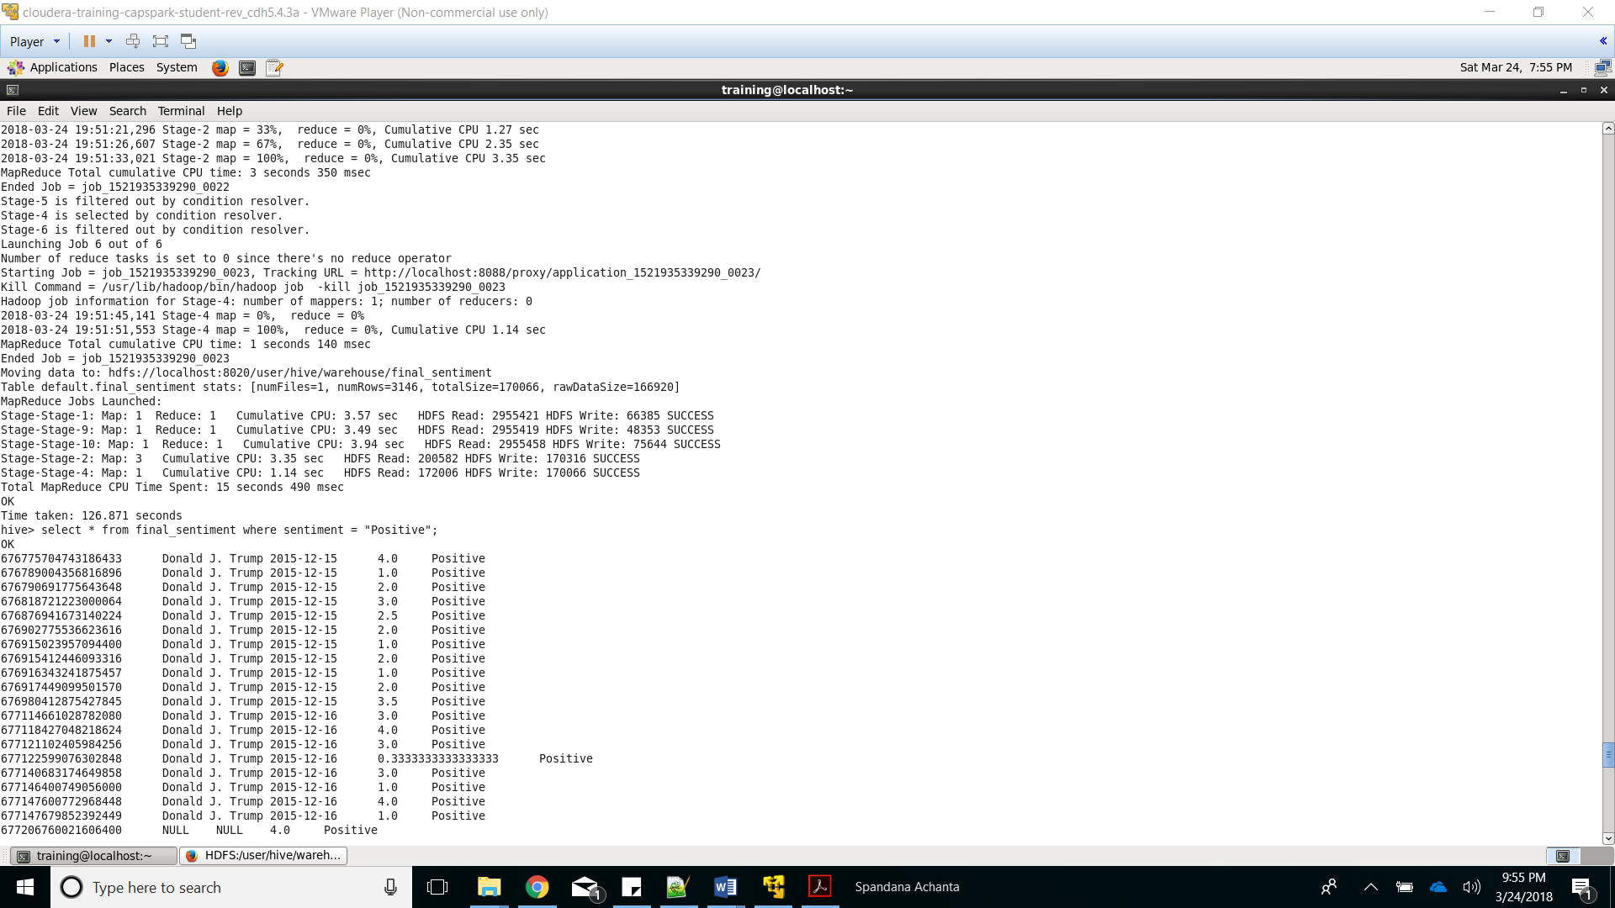

Verifying contents of the Final_Sentiment Table